US Road Safety, Spending, and Taxation: A State-Level Analysis of Fatality Rates and Fiscal Patterns
Name

Contents
1. Introduction 2
2. Research Questions 2
3. Methodology 3
4. Visual Analysis of Insights 4
5. Key Findings 8
6. Conclusion 9
7. Additional Research Questions 10
8. References 11

1. Introduction
Road safety and road-finance decisions are tightly intertwined in the United States. State governments must decide how much to spend on highways, how to raise those funds through fuel taxes or other road-user revenues, and how to ensure that these investments translate into safer travel. The available dashboards and datasets provide a focused snapshot of these relationships for 2023, supported by historical fatality data from 2010–2023 and state-level information on population, highway expenditures, road-tax funding shares, and GDP per capita.
By combining these data sources, it becomes possible to examine not only which states are the safest or most dangerous for drivers, but also whether affluence, population size, and road-spending patterns help explain differences in fatality rates. The report uses the state-level figures on fatalities, spending, population, tax coverage and income to build an integrated view of road safety as both a transportation and a socio-economic issue.
This analysis is organized around research questions, methodology, visual findings, and implications for policy and future research.

2. Research Questions
From the dashboards and datasets, the following research questions are proposed:
- How have U.S. road-fatality rates per 100 million vehicle miles traveled (VMT) evolved from 2010 to 2023, and what anomalies appear in the trend?
- Which states exhibit the highest and lowest fatality rates in 2023, and how do these states compare in terms of population, income per capita, and road-expenditure levels?
- What is the relationship between road-tax funding (the percentage of state and local road expenditures covered by roadway revenues) and road-expenditure levels across states?
- Do higher road-expenditure levels and higher income per capita correlate with lower fatality rates?
- How do population size and growth interact with road-fatality rates—do more populous states necessarily experience higher fatality risk per VMT?
These questions frame the remainder of the report and guide the quantitative analysis.

3. Methodology
Data sources
The numeric analysis in this report uses the following CSV files:
- “Fatality Rate per 100 million Vehicle Miles.csv” – state-level fatality rates from 2010–2023.
- “Population by state.csv” – state populations from 2020–2024.
- “Highway and Road Expenditures by States.csv” – a cross-section of highway and road expenditures per state (labeled as “Highways”).
- “Road Taxes and Funding by State, 2025.csv” – the percentage of state and local (S&L) expenditures on roads that are covered by roadway revenues (taxes, tolls, fees), plus a rank.
- “GDP Per Capita by States .csv” – income per capita for each state by year, including 2023.
External references from USDA ERS, BEA, FRED, World Population Review, and NIMHD’s HDPulse portal provide broader economic and social context for income, consumption, and poverty and are cited in the reference section.
Data cleaning and processing
All datasets were imported into Python and cleaned as follows:
- Type conversion and formatting
  - Highway expenditure values such as “1,138” were stripped of commas and converted to numeric “Highways_num” values.
  - Percentages in the tax dataset (e.g., “74.90%”) were converted to numeric “pct” values such as 74.9.
  - “Income Per Capita” values were converted from strings with commas to floating-point numbers.
- Harmonizing state names
  - In the highway dataset, the column “Region and State” was renamed to “State”.
  - In the population dataset, the column “States” was also renamed to “State” for merging.
- Filtering to 2023 for cross-sectional analysis
  - For fatalities, populations, and GDP per capita, only the year 2023 was retained for state-level comparisons.
  - The fatality time series from 2010–2023 was preserved separately for trend analysis.
- Merging datasets
  - A master 2023 table was created that merged fatality rate, population, road-expenditure level, road-tax percentage, and income per capita by state.
  - Two states, Alaska and Hawaii, did not appear in the highway-expenditure file and therefore dropped out of analyses that require all variables simultaneously. The national “USA” aggregate in the fatality dataset was also excluded from state-level correlations. The final merged file contains 49 observations (48 states plus the District of Columbia).
- Statistical summaries
  - Pearson correlations were calculated between fatality rates and each of the other variables (population, highway expenditures, road-tax coverage, and income per capita).
  - Descriptive statistics and state rankings were generated to support the narrative.
This methodology ensures that all conclusions are based on consistent, comparable measures across states and overtime.

4. Visual Analysis of Insights
National fatality trend, 2010–2023
When fatality rates per 100 million VMT are averaged across states, the national trend from 2010 to 2019 is mostly downward with small fluctuations. The mean rate falls from about 1.17 in 2010 to roughly 1.10 in 2019, reflecting gradual improvements in road safety, vehicle technology, and enforcement.
However, the time series shows a clear pandemic-era spike: the national average jumps to about 1.31 in 2020 and peaks around 1.32 in 2021, before easing slightly to 1.30 in 2022 and 1.24 in 2023. Reduced traffic volumes during the pandemic appear to have been offset by higher speeds and riskier driving behaviors, raising fatalities per mile driven. The 2023 value indicates a partial but incomplete reversal of this spike.
Geographic variation in 2023 fatality rates
The 2023 state ranking highlights stark regional differences. The top five states by fatality rate are:
- Mississippi – 1.79 fatalities per 100 million VMT
- Arizona – 1.73
- South Carolina – 1.72
- Kentucky – 1.66
- West Virginia – 1.63
Most of these high-fatality states are in the South or border-South, with a mix of extensive rural road networks, lower seatbelt usage in some cases, and higher rates of risky behaviors such as impaired or speeding driving.
The bottom five states—those with the lowest fatality rates—are:
- Massachusetts – 0.56
- Minnesota – 0.70
- New Jersey – 0.78
- Utah – 0.81
- Wisconsin – 0.87
These states tend to have more urbanized populations, better trauma-care access, stringent enforcement, and higher per-capita income, all of which are likely to contribute to safer outcomes.
Population and fatality rates
From 2020–2023, state populations increase steadily, while the national average fatality rate rises slightly through 2022 and then dips in 2023.
Using the merged dataset, state population size itself is only weakly related to fatality rate in 2023: the correlation between state population and fatality rate is about –0.02, essentially zero. Very small states like Vermont and Wyoming do not systematically have higher or lower risk than very large states like California or Texas once the metric is normalized per 100 million vehicle miles.
This indicates that higher population leads to more total fatalities, but not necessarily to a higher rate of fatalities per mile driven. Fatality risk per mile appears to be driven more by behavior, infrastructure quality and enforcement than by the size of the population.
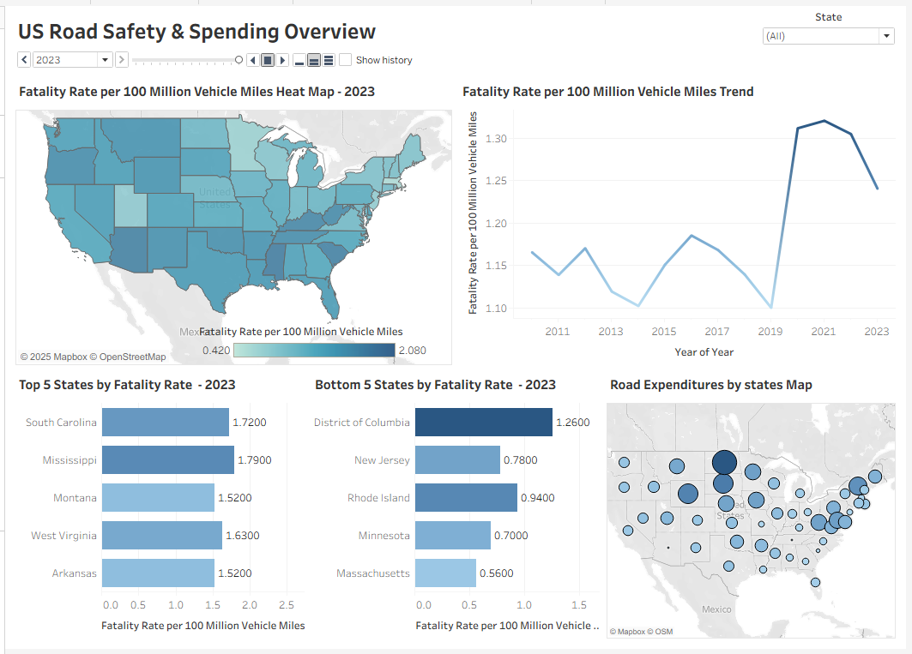
Road expenditures and road-tax funding
A scatterplot of road expenditures vs road-tax collected plots road expenditures on the x-axis and the percentage of S&L expenditures covered by roadway revenues on the y-axis. In the data, this percentage ranges from under 30% to 100%.
Statistical analysis shows a moderate negative correlation (~ –0.51) between highway expenditure level (Highways_num) and the funding-share percentage. States that spend heavily on highways tend to finance a smaller share of those expenditures through direct road-user revenues and rely more on general funds or external sources. Conversely, states with lower road expenditures often cover a larger percentage of those costs through fuel taxes, tolls, and related revenues.
The top tax-covering states—with 100% of S&L expenditures funded by roadway revenues—are Delaware, Montana, and New Jersey. South Carolina follows at about 99.1%, and Ohio at 99.0%. These states have chosen funding models in which road users bear almost the entire cost of road infrastructure, at least in accounting terms.
Expenditures, income, and fatality outcomes
To examine whether spending and prosperity lead to safer roads, fatality rates were correlated with both highway expenditures and income per capita (2023).
- The correlation between fatality rate and highway expenditures per state is about –0.11. This is a weak negative relationship: states that spend somewhat more on highways tend to have slightly lower fatality rates, but the effect is small and not decisive.
- The relationship between fatality rate and income per capita is much stronger. The correlation is approximately –0.60, indicating that higher-income states generally experience lower fatality rates.
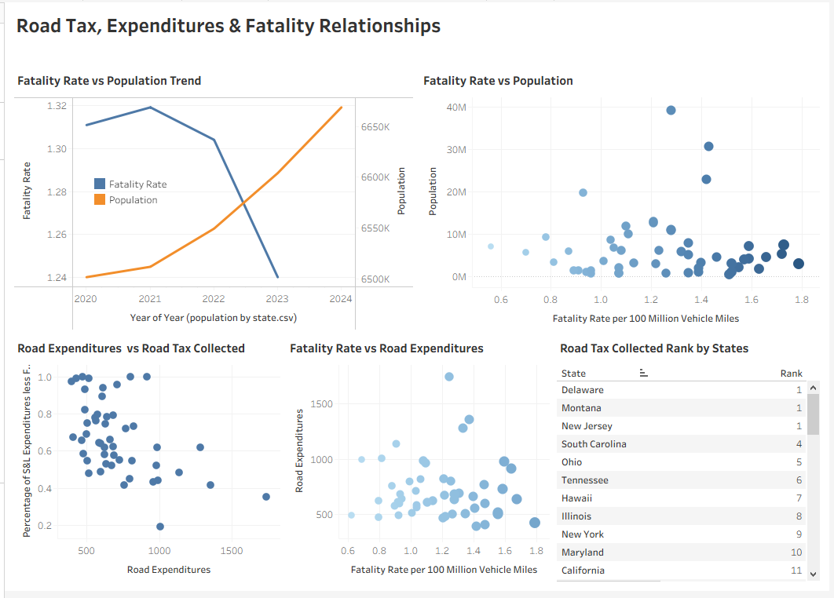
The lists of top and bottom fatality states illustrate this pattern clearly. Among the high-fatality group, Mississippi has an income per capita of about $55,060, Kentucky about $61,980, and West Virginia about $60,410, below the national high-income leaders. In contrast, the lowest-fatality states are also some of the most affluent: Massachusetts (~$106,500), New Jersey (~$91,590), Utah (~$101,200), and Minnesota (~$90,340) all sit well above the median income per capita.
These patterns suggest that broader socio-economic conditions—such as economic opportunity, education, enforcement capacity and health-care access—are powerful drivers of road-safety outcomes.
Maps of fatality rates and expenditures
The “Fatality Rate per 100 million Vehicle Miles” heat map for 2023 shades states according to their fatality risk. Darker states in the Deep South and parts of the interior correspond to the high-fatality states already identified, while lighter shades in the Northeast, Upper Midwest and parts of the Mountain West reflect lower fatality rates.
The “Road Expenditures by States” map highlights state with especially high outlays on highways. Examples include North Dakota, South Dakota, Wyoming, and Vermont, all of which show high values in the “Highways” metric. Some large coastal states such as California and New Jersey fall closer to the middle of the expenditure distribution despite having much larger populations, indicating that spending is not simply proportional to the number of residents.
Overall, the visualizations and the underlying data jointly reveal substantial variation across states in both the resources devoted to roads and the safety outcomes experienced by road users.

5. Key Findings
- Pandemic-era reversal of long-term safety gains
From 2010–2019, average fatality rates per 100 million VMT declined modestly, but 2020–2022 saw a clear spike, with rates around 1.31–1.32 before easing to 1.24 in 2023. Road-safety progress remains fragile.
- Large state-to-state disparities in fatality risk
In 2023, fatality rates range from 0.56 in Massachusetts to 1.79 in Mississippi—a more than three-fold difference. Regional clustering is evident: many high-risk states are in the South and interior, while low-risk states are concentrated in the Northeast and Upper Midwest.
- Income per capita is strongly associated with road-safety outcomes
A correlation of approximately –0.60 suggests that higher-income states tend to have lower fatality rates. The safest states are also among the most affluent, while several of the most dangerous states exhibit relatively low income per capita.
- Road-expenditure levels show only a weak safety relationship
Higher highway expenditures are associated with slightly lower fatality rates (correlation about –0.11), but the effect is small and overshadowed by socio-economic factors. Simply spending more on roads does not guarantee safer outcomes, the composition and effectiveness of that spending matter.
- Road-tax funding shares are inversely related to expenditure levels
States with very high percentages of road expenditures covered by roadway revenues (e.g., Delaware, Montana, New Jersey) often have moderate expenditure levels. Heavy-spending states more frequently rely on broader revenue sources, as indicated by a –0.51 correlation between expenditure and funding share.
- Population size does not drive fatality rates per mile
State population is essentially uncorrelated with fatality rate per 100 million VMT in 2023. Large states like California and Texas do not inherently have higher risk per mile than smaller states; instead, total fatalities rise with population, while the normalized rate is driven by behavior, infrastructure, and enforcement.
- Data gaps limit some comparisons
Alaska and Hawaii appear in the fatality, income, and population datasets but are missing from the highway-expenditure file, limiting the ability to compare their spending–safety relationships to those of other states.

6. Conclusion
The combined evidence from the dashboards and datasets underscores that road safety is not determined by any single factor. Over the last decade, the United States made incremental progress in reducing fatalities per mile traveled, yet the pandemic period abruptly reversed much of that progress. Although 2023 shows a modest improvement from the 2020–2022 peak, fatality rates remain above pre-pandemic levels, suggesting that risky driving behaviors and structural vulnerabilities have not fully normalized.
State-level comparisons reveal stark inequality: drivers in Mississippi, Arizona, South Carolina, Kentucky, and West Virginia face more than triple the fatality risk per mile of drivers in Massachusetts. These differences closely track broader socio-economic patterns with higher income per capita, more urbanized populations, and stronger institutions generally achieve safer roads. The strong negative correlation between income per capita and fatality rate indicates that road safety should be viewed as part of a wider social and economic development agenda, not just an engineering problem.
At the same time, the data show that spending more money on highways alone is not sufficient. While there is a slight tendency for higher-spending states to enjoy lower fatality rates, the correlation is weak, and some high-spending states still experience substantial risk. Rather than focusing solely on expenditure totals, policymakers should emphasize targeted investments in proven safety interventions such as access-controlled highways, safer intersections, pedestrian infrastructure, enforcement technology, and trauma-care improvements.
Finally, road-tax funding structures vary greatly across states. Some, like Delaware, Montana, and New Jersey, fully cover road expenditures with roadway revenues, while others depend heavily on general funds or federal support. These choices can influence public and political support for safety-oriented investments. Overall, the analysis highlights the importance of integrating economic, fiscal, and social data into road-safety strategies and suggests rich opportunities for more detailed future research.

7. Additional Research Questions
- How do specific types of road expenditures (maintenance vs new construction vs safety programs) relate to changes in fatality rates over time within each state?
- What is the role of urbanization, vehicle mix (e.g., share of heavy trucks or motorcycles), and road-class composition (rural vs urban, local vs interstate) in explaining state-level fatality differences?
- How do poverty rates and other social determinants of health—such as education levels, health-care access, or racial/ethnic disparities—interact with income per capita to influence road-safety outcomes?
- Do changes in road-tax rates or tolling policies lead to measurable shifts in driver behavior and safety, beyond their impact on revenue levels?
- How do U.S. state outcomes compare to similar regions in other countries when normalized for income, vehicle ownership, and road-network structure?
- Can machine-learning models using multi-year panel data (fatalities, expenditure categories, enforcement variables) predict which interventions will yield the greatest safety improvements per dollar spent?

8. References
- Tax Foundation. (n.d.). State highway and road taxes & funding. Tax Foundation. https://taxfoundation.org/data/all/state/state-road-taxes-funding/
- National Highway Traffic Safety Administration. (n.d.). Fatalities and fatality rates by state. Fatality Analysis Reporting System (FARS). https://www-fars.nhtsa.dot.gov/States/StatesFatalitiesFatalityRates.aspx
- Urban Institute. (n.d.). Highway and road expenditures. State and Local Finance Initiative. https://www.urban.org/policy-centers/cross-center-initiatives/state-and-local-finance-initiative/state-and-local-backgrounders/highway-and-road-expenditures
- U.S. Census Bureau. (n.d.). County population totals: 2020–2023 [Data set]. https://www.census.gov/data/tables/time-series/demo/popest/2020s-counties-total.html
- Bureau of Economic Analysis. (n.d.). GDP by county, metro, and other areas [Data set]. https://www.bea.gov/data/gdp/gdp-county-metro-and-other-areas

